Effect of mineral particle size on microwave heating: from experiment to numerical simulation

# **Peter Chen, Chunshun Zhanga\***

aDepartment of Civil Engineering, Monash University, Clayton, VIC 3800, Australia

# **Corresponding author: Chunshun Zhang;** [**Ivan.Zhang@monash.edu**](mailto:Ivan.Zhang@monash.edu)

# **Abstract:**

**It has been validated experimentally that the ability of minerals to absorb Microwave energy is linearly related to its particle size, through heating various different minerals air mixer in the microwave oven[1]. In fact, the literatures have shown many contradictory results due to different particle characteristics, environment setup and different measurement methods. [2, 3] But currently, there are no consensus in the factors that’s causing it, which limits the further research into the quantifying the relationship. It is argued by some researchers that the inter particles reflection is the major factor in ability of rock minerals to absorb EM wave[1]. While others argue that the Skin Effect plays an important role. Maximizing microwave absorption in a fuel and oxidizer composite mixture could be accomplished by minimizing the metal-oxide particle size and choosing the optimum particle size for the fuel based on the ratio of skin depth to particle size[3]. Our research aimed at using numerical simulation to investigate the underlying physical laws that between the particle size and the EM wave absorption. MEEP open source software, which employs Finite Difference Time Domain (FDTD) method, was used for simulation. The different geometry constructions are achieved through Python. The impacts of various assumption such as the simulation time, resolution and transient time in the simulation was also investigated. Through this, this paper aimed at explaining some of the factors that affect the absorption through simulation.**

Keywords: EM simulation, numerical simulation, rock breakage, Microwave assisted rock breakage, comminution

# Introduction

Thorough tremendous development in comminution, the lives of the cutter blades have been greatly extended. However, Mechanical method of rock breakage requires large amount of energy due to the high strength of the rock. The excessive high wear of the blade in abrasive or hard rock presents huge challenge to this method of rock breaking. [1]

Microwave can function as an assistant process to the mechanical breakage of rock. Previous research has established the cost saving and efficiency improvements to the comminution. [1] The more complex 3D numerical simulation found that the Microwave can induce significant stress in the inhomogeneous rock samples. The pre-processing heating and cooling of the rock greatly reduce the strength required for the boring process. [4]

However, the process of microwave within the rock is not well understood. The goal of this paper is to understand the effect particle size (ranging from 50um to 3cm, which covers most of the rock particle sizes) has on the heating rate. The effect of the ratio between gaps size particles size have on the absorption on the EM wave is also investigated.

# Methodology

The simulation undertook in this experiment involves the use of MEEP, an industrial state-of-the-art simulation platform for Electromagnetic fields simulation.

## Geometric Construction Setup

4 different geometry shapes, namely circle, triangle, hexagon and cube, are chosen to characterize the majority of the particle shapes that occur in nature.

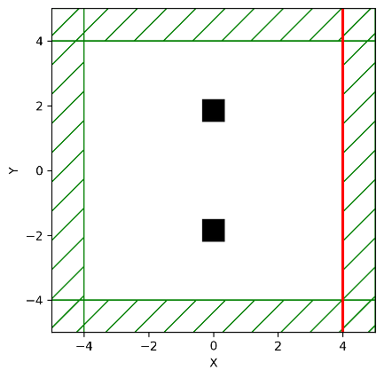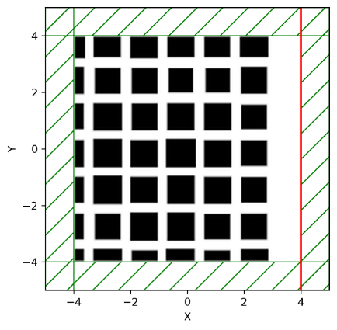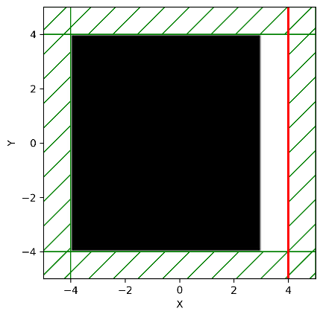

Figure 2.1 Simple geometry (a), checker geometry (b), and effective medium geometry (c)

The simple geometry contains 2 identical particles of different the configurations include different particle sizes, shapes and different distant between the particles. Figure 2.1(a)

Complex geometry involves array of geometry shape evenly distributed inside the medium. This distribution more closely resembles the real-life rock formation. The particle size and dielectric constant are randomized using Gaussian distribution. Figure 2.1(b)

Effective medium geometry is where a single particle is placed at the center of the simulation domain. It is used for particles that are too small for the simulation finite difference method. The effective medium is calculated from Equation 3.3, the dielectric property for the rock particles are taken from the measurement made by Zheng [1]. Figure 2.1(c)

When one parameter such as the particle size or fill factor is investigated, other parameters are kept constant to ensure the integrity of the results.

## Electromagnetic Simulation Setup

The MEEP is an open source Finite Difference Time Domain (FDTD) software. The source frequency is 2.45 GHz. Plane wave is used for the simulation. The size of the simulation cell is 10cm. The PML is 1cm, the transition zone where results are discarded is 1 cm to ensure the edge effect is minimized. The for simulation is 1000 (MEEP timestep). The transient time is estimated with the EM field RMS plotting. The transient results are discarded. The simulation step is select to be less than half of the simulation frequency to avoid aliasing of high frequency wave.

## Result Processing Setup

$$E_{RMS}=\iint{\int_{stop}^{step}{E^{2} dt}dA}$$

Equation 2.1 Numerical integration of simulation results

The mean is calculated from the 2D EM field squared integrated over time Equation 2.1. Since we assume at the absorption of the matrix material is low compare to the absorption of the particles, the area of integration is exclusive where the particles lie. The results are integrated using Python trapezoid function over time domain and spatial domain. The mean value is an ideal indicator on the EM field within the sample.

# results and discussions

## wave propagation and skin effect inside particles

How is the wave propagated inside the particles? What kind of distribution it has.

Single particle, multiple particles absorption, reflection. From a microscopic perspective.

How the contour plot of the microwave strength inside the particles.

Different filling factors.

## Particle Size, Gap Size and Influence on EM field Absorption

Using the simple geometry simulation, 2 particles of different size are placed at the various distance apart and 2 cm from the source. The size of the particles and the distance between them are varied while other factors are kept at a constant.

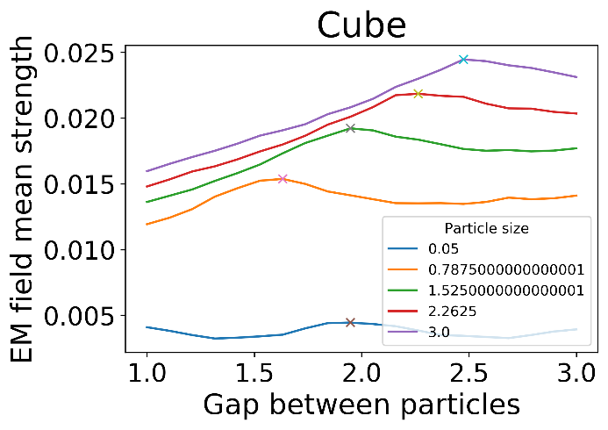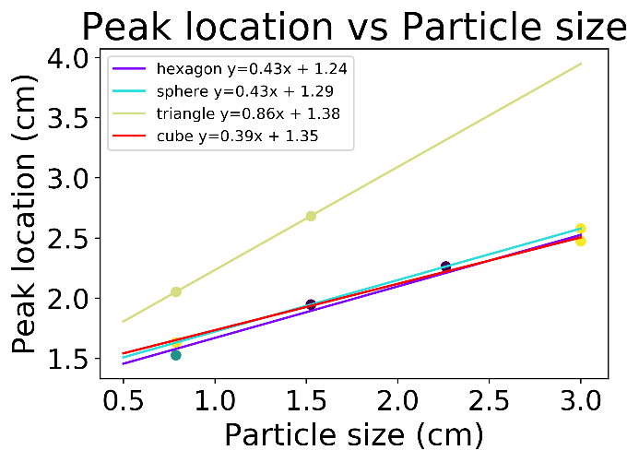

Figure 3.1 Particle size and gap vs mean EM field strength (a) The peak location vs gap size (b)

It can be seen from Figure 3.1(a) that different size particles result in different peak EM field stress location. The location of the peak of the EM field strength is closely related to the size of the particle. As the size of the particles increases, the gaps length at which the maximum electrical field strength peaks increases as well. The outlier of particle size at 0.05 is excluded because that the particle size difference is too large that the first peak EM field location is outside the range of the gap sizes.

The linear regressively fitting line is displayed at Figure 3.1(b). Sphere, cube, hexagon have similar relationship and constants. While triangle has 2 times the gradient compares to the other shaped.

We can draw the conclusion that the ratio between the gap size and particles size have a big impact on the EM wave absorption rate. When the sizes of the particles increase, the peak absorption gap size increase as well.

This will allow us to identify and evaluate the impact of the rock composition on EM absorption more accurately. When the statistical characteristics of the particles (size, gaps size, shape) is knowledge. Different strength and frequency of the EM wave can be administrated to help conserve energy and ensure maximum rock breaking efficiency.

## Particle Size, Fill Factor and influence on EM field Absorption

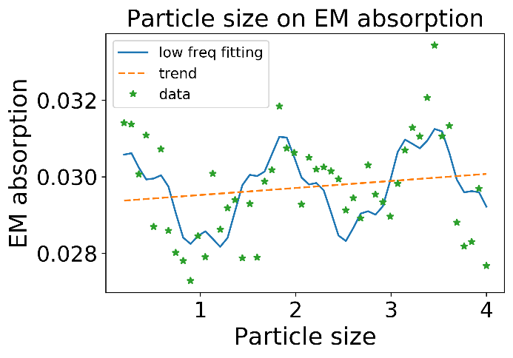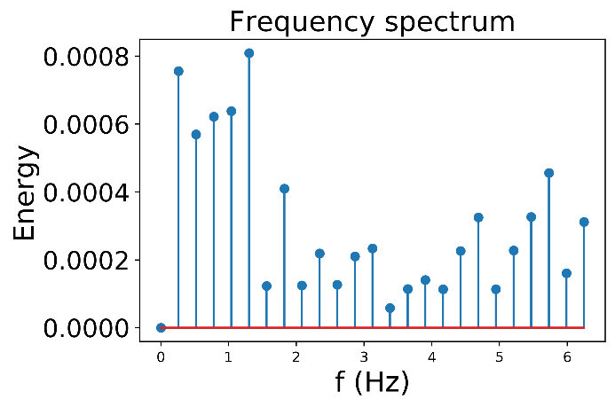

Figure 3.2 Particles size and mean EM field strength (a) and frequency decomposition (b)

|  |  |  |  |
| --- | --- | --- | --- |
|  | A | f | $$ϕ$$ |
| Sin1 | -11.7x10-4 | 0.66 | 3.43 |
| Sin2 | -3.51x10-4 | 2.43 | 1.31 |

|  |  |
| --- | --- |
| k (gradient) | 2.4x10-4 |
| c (constant) | 2.91x10-2 |

Table 3.1 Low frequency decomposition of data

$$f\left(x\right)=\sum_{n=1}^{2}{\left(A_{n}\sin{2πfx+ϕ}\right)}+kx+ c$$

Equation 3.1 Low frequency approximation

$$\frac{ΔT}{t}=\frac{2πfε}{C_{P}ρ}ε''E^{2}$$

Equation 3.2 EM field strength and heating rate [1]

Using the complex geometry simulation and the all other factors kept at constant, the particle size is swept. The mean strength of the EM field has strong constant component, which means that the contribution of particle size on the change of EM field absorption is relatively low. However, there are periodic changes of the mean field strength, which can be seen in the frequency decomposition Figure 3.2(a). where the low frequency has strong energy. Thus, using low frequency decomposition Equation 3.1, we would be able to find the relatively good representation of the data using composition of sine wave and linear function as presented in Table 3.1. It is interesting to see that the main energy in the frequency spectrum is centred around 0.82 Hz as seen in Figure 3.2(b), which is the source frequency used in the simulation. We hypothesis that the fluctuation is due to particular frequency of Microwave reflects within the rock particle matrix at the particular gaps size ratio, causing standing wave and increase the absorption.

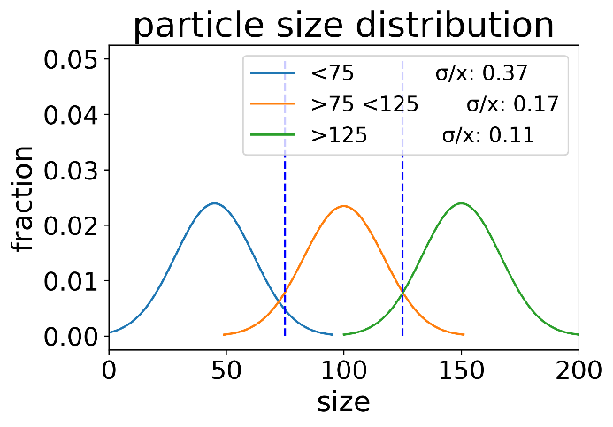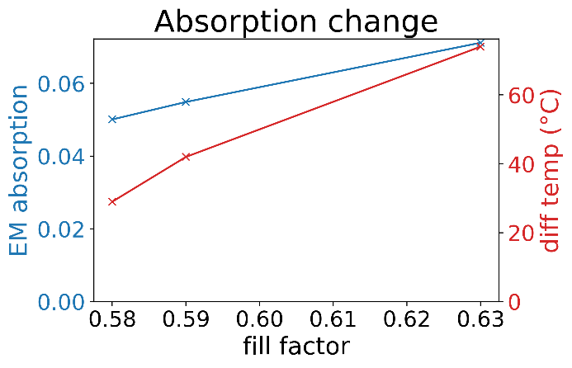

Figure 3.3 Particle size distribution (a), filling factor influence on the EM absorption (b)

$$K_{A}=\frac{\left(2-3f\right)K_{T}-2K_{eff}}{\left(1-3f\right)K_{eff}-K_{T}}K_{eff}$$

Equation 3.3 Bruggeman’s effective medium theory [5]

|  |  |  |  |  |  |
| --- | --- | --- | --- | --- | --- |
| Particle size | Normalized σ | Fill Factor | Effective medium | Temperature change (° C) | Simulated EM absorption |
| <75 | 0.37 | 0.63 | 4.16+0.032i | 74 | 0.071169183 |
| >75 <125 | 0.17 | 0.59 | 3.86+0.028i | 42 | 0.054883161 |
| >125 | 0.11 | 0.58 | 3.78+0.027i | 21 | 0.050084988 |

Table 3.2 Different geometry distribution and EM absorption

Due the low magnitude of the oscillation of the mean EM wave strength, we concluded that the heating rate difference is mainly caused by the different filling factor of the particles. Filling factor of the particles are strongly affected by the particle size distribution rather than the particle size itself [5]. During the experimental setup, different size particles are separated through sifting [1]. Gaussian distribution approximation of particle size is calculated Figure 3.3(a). The ratio between standard deviation and mean is calculated. The ratio is then used to lookup the fill factor[5]. The filling factor is used to calculate the effective medium with Bruggeman’s Equation 3.3 Table 3.2. Simulations of different filling factors are performed with the effective medium geometry. The thermal energy has linear relationship with the squared EM field mean strength and the effective absorption factor, according (Eq. 3.2). Thus, the EM absorption rate is the product of effective loss factor and EM mean strength.

The temperature is drawn from Zheng’s experiment [1]. The simulation agrees with the experiment quite well Figure 3.3(b). As the sifted particle size increase, the filling factor decrease and the EM absorption decreases. This validate our hypothesis that the filling factor (and thus effective medium) is the major contributing factor to the different heating rate of different particle size. Thus, during the process of microwave assisted rock breakage, measurement of the effective medium can be a good indicator on the effectiveness of microwave heating. Microwave can be applied when the rock can respond to the microwave heating effectively.

$$x=\frac{L}{1+e^{-k\left(x-x_{0}\right)}}+b$$

Equation 3.5 Sigmoid fitting Equation

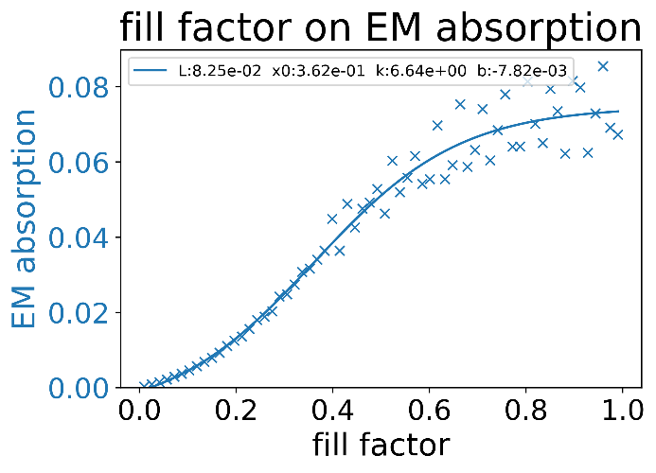

Figure 3.4 Mean EM field absorption vs filling factors

When the fill factor is increased or decreased further, correspond to the microwave wave absorbing particle sparsely or densely packed within the rock matrix, the EM absorption show tapering off at both ends Figure 3.4. The relationship between filling factor and EM absorption can be fitted with Sigmoid function Equation 3.5. This is because at low filling factor, the increase of filling factor retains more microwave locally, thus showing a compounding effect. But at higher filling factor, majority of the EM wave energy is absorbed. Thus, further increase in the filling factor does not contribute significantly to the increase in EM absorption strength.

# Conclusions

**This paper furthers the understanding of the relationship between characteristics of the particles and its absorption abilities of EM wave.** Different factor affecting the microwave absorption in the rock air mixture is investigate. The RGSPS (ratio of size of the gap between particles and particle size) is found to have strong impact on the microwave absorption rate. This is due to the wave reflection and refraction between the particles. There are a fixed RGSPS associated with the maximum EM wave absorption for the particles of certain geometry. It is also found that particle size is not the major contributing factor of rate EM wave absorption. The filling factor, and as a result effective medium dielectric property of the rock is the major contributing factor of the absorption difference. The simulation with different dielectric property agrees well with experiment. We further extended the range of filling factor and found that filling factor increase in the 25% to 50% correspond to the maximum ROC in absorption. This is due to the inability of rock to retain EM field at lower filling factor and total absorption at high filling factor. These founding five us a deeper understanding of the underlying physics in the process of microwave absorption of rocks. The quantitative relationship between the particles size, filling factor, gap size and the mean EM field strength can increase our capacity in predicting the response of the rock particles under the irradiation of microwave. The simulation chain can provide fast and accuracy estimation on the relationship between many different parameters. It can be even extended much more complex experimental setup and provide much cleaner testing environment.

# Acknowledgement

The work described in this paper was supported by a grant from Chunshun Zhang

# References

[1] Y. ZHENG, "Fracturing of Hard Rocks by Microwave Treatment and Potential Applications in Mechanised Tunnelling," Doctor of Philosophy, Monash PHD thesis, Monash University, 2017.

[2] V. Rizmanoski, "The Effect of Microwave Heating on Ore Sorting," Doctor of Philosophy, Sustainable Minerals Institute Julius Kruttschnitt Mineral Research Centre University of Queensland, 2012.

[3] C. A. Crane, M. L. Pantoya, B. L. Weeks, and M. Saed, "The effects of particle size on microwave heating of metal and metal oxide powders," *Powder Technology,* vol. 256, pp. 113-117, 2014/04/01/ 2014, doi: <https://doi.org/10.1016/j.powtec.2014.02.008>.

[4] M. Toifl, R. Meisels, P. Hartlieb, F. Kuchar, and T. Antretter, "3D numerical study on microwave induced stresses in inhomogeneous hard rocks," *Minerals Engineering,* vol. 90, pp. 29-42, 2016/05/01/ 2016, doi: <https://doi.org/10.1016/j.mineng.2016.01.001>.

[5] H. Y. Sohn and C. Moreland, "The effect of particle size distribution on packing density," *The Canadian Journal of Chemical Engineering,* vol. 46, no. 3, pp. 162-167, 1968/06/01 1968, doi: 10.1002/cjce.5450460305.